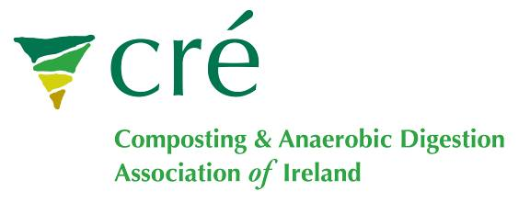
AD Europe 2011 Thursday 24 & Friday 25 February 2011, Crowne Plaza Hotel, Ireland

BOOKING FORM
Mr./Ms. & Name
Organisation
Address
E-Mail

Fee
EARLY BIRD RATES-BOOK BEFORE JANURARY 20TH
 | Members of ECN/CRE/EBA/IrBEA  Members | Non member  Members
One Day Pass | €150 | €175
Two Day Pass | €225 | €250
STANDARD RATES
 | Members of ECN/CRE/EBA/IrBEA  Members | Non member  Members
One Day Pass | €175 | €200
Two Day Pass | €250 | €275
EXHIBITION SPACE | €100 | €150
NETWORKING DINNER | €30 | €30
STUDENT (copy of student card required) | €75 | €75
*All rates are exclusive of VAT at 21%

Payment Must be Received Before the Event Takes Place to Secure Your Booking

Please State which Day(s) you wish to Attend (e.g. Thursday 21st at early bird rate of €150)
Answer:
Do you wish to have an exhibition space? Answer: (YES/NO)
Please note that Exhibitors pay the normal delegate rate too.

Cancellations / Substitutions
For those unable to attend, a substitute delegate may be sent at any time for no additional charge. Alternatively a refund will be given for cancellations received in writing, by fax or letter, up to 7 days prior to the event. Regrettably no refunds can be made after that date.

Value Added Tax
As the conference is held in the Republic of Ireland, VAT is applicable @ 21% for all delegates, including those attending from outside the Republic of Ireland. This position has been verified by the Revenue Commissioners. International delegates can reclaim VAT under the 8th VAT Directive. Cré – Composting Association of Ireland VAT number is 6390931I.

Delegate Fee €
Exhibition Fee €
Network Dinner Fee €
Vat @ 21% in €
Total Amount €

Cheque Enclosed:(Yes/NO) Purchase Order No:_________ Bank Transfer: (Yes/NO)

Post/email booking form to John Brennan at Cré- Composting Association of Ireland, Po Box 13, Dundalk, Co. Louth, Ireland
Tel: 00353 (0) 86-8129260 Email:john@cre.ie

Bank Transfers (Pay in Euros):
Please use the IBAN and Swift code to reduce your transfer costs
Account Name: Cré-Composting Association of Ireland
Address of Account Holder: PO Box 13, Dundalk, Co. Louth, Ireland
Bank Name: AIB
Address of Bank: Clanbrassil Street, Dundalk, Co. Louth, Ireland
Bank Code: 932450
Account Number: 66821039
BIC/Swift Code: AIBKIE2D
IBAN: IE26 AIBK 9324 5066 8210 39
PLEASE Reference: your name & <your-email@address>

